

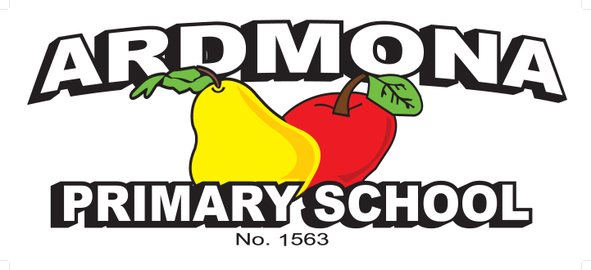
Yard Duty and Supervision Policy

Purpose
To ensure school staff understand their supervision and yard duty responsibilities.

Scope
This policy applies to all teaching and non-teaching staff at Ardmona Primary School, including education support staff, casual relief teachers and visiting teachers.

Policy
Appropriate supervision is an important strategy to monitor student behaviour and enables staff to identify and respond to possible risks at school as they arise. It also plays a vital role in helping schools to discharge their duty of care to students.
The principal is responsible for ensuring that there is a well-organised and responsive system of supervision in place during school hours, before and after school, and on school excursions and camps.
School staff are responsible for following reasonable and lawful instructions from the principal, including instructions to provide supervision to students at specific dates, time and places.

Before and After School
Ardmona Primary School’s classrooms are supervised by school staff from 8.30am before school and up until 3.30pm at the end of day pick up area after school.
Parents and carers should not allow their children to attend Ardmona Primary School outside of these hours.
Our school commits to providing to the carer advise of the supervision arrangements before school.
- request that the parent/carer make alternate arrangements where staff are not on duty.
If a student arrives at school before supervision commences at the beginning of the day, the principal or nominee staff member will, as soon as practicable, follow up with the parent/carer to:
- advise of the supervision arrangements before school
- request that the parent/carer make alternate arrangements.
If a student is not collected before supervision finishes at the end of the day, the principal or nominee staff member will consider whether it is appropriate to:
- attempt to contact the parents/carers
- attempt to contact the emergency contacts

- place the student in an out of school hours care program (if available)
- contact Victoria Police and/or the Department of Health and Human Services (Child Protection) to arrange for the supervision, care and protection of the student
School staff who are rostered on for before or after school supervision must follow the processes outlined above.

Yard Duty
All staff at Ardmona Primary School are expected to assist with yard duty supervision and will be included in the weekly roster.
The principal is responsible for preparing and communicating the yard duty roster on a regular basis. At Ardmona Primary School, school staff will be required to monitor the entire school area.
Staff who are rostered for yard duty must remain outside until they are replaced by a relieving teacher.

Yard Duty Equipment
School staff must:
- always carry the yard duty first aid bag during supervision. The yard duty first aid bag will be stored in the first aid cupboard.
Yard duty equipment must be returned after the period of supervision or handed to the relieving staff member.
During yard duty, supervising staff must:
- methodically move around the designated zone ensuring active supervision of all students
- where safe to do so, approach any unknown visitor who is observed on school grounds without a clear legitimate purpose, and ensure they have a visitor pass and have signed in (excluding drop off and collection periods)
- be alert and vigilant
- intervene immediately if potentially dangerous or inappropriate behaviour is observed in the yard
- enforce behavioural standards and implement appropriate consequences for breaches of safety rules, in accordance with any relevant disciplinary measures refer Student Engagement and Wellbeing Policy
- ensure that students who require first aid assistance receive it as soon as practicable
- log any incidents or near misses as appropriate on CASES.
If being relieved of their yard duty shift by another staff member (for example, where the shift is ‘split’ into 2 consecutive time periods), ensure that a brief but adequate verbal ‘handover’ is given to the next staff member in relation to any issues which may have arisen during the first shift.
If the supervising staff member is unable to conduct yard duty at the designated time, they should contact the principal with as much notice as possible prior to the relevant yard duty shift to ensure that alternative arrangements are made.

If the supervising staff member needs to leave yard duty during the allocated time, they should contact the principal but should not leave the designated area until the relieving staff member has arrived in the designated area.
If a relieving or next staff member does not arrive for yard duty, the staff member currently on duty should send a message to the office/principal and not leave the designated area until a replacement staff member has arrived.
Should students require assistance during recess or lunchtime, they are encouraged to speak to the supervising yard duty staff member.

Classroom
The classroom teacher is responsible for the supervision of all students in their care during class.
If a teacher needs to leave the classroom unattended at any time during a lesson, they should first contact principal for assistance. The teacher should then wait until another staff member has arrived at the classroom to supervise the class prior to leaving.

School Activities, Camps and Excursions
The principal and leadership team are responsible for ensuring that students are appropriately supervised during all school activities, camps and excursions. Appropriate supervision will be planned for special school activities, camps and excursions on an individual basis, depending on the activities to be undertaken and the level of potential risk involved and will follow the supervision requirements in the Department of Education and Training Excursions Policy.

Digital Devices and Virtual Classroom
Ardmona Primary School follows the Department’s Cybersafety and Responsible Use of Technologies Policy with respect to supervision of students using digital devices.
Ardmona Primary School will also ensure appropriate supervision of students participating in remote and flexible learning environments while on school site. In these cases, students will be supervised where students will undertake virtual and remote learning while at school in the classroom or upstairs virtual monitor room.
While parents are responsible for the appropriate supervision of students accessing virtual classrooms from home:
- student attendance will be monitored
- any wellbeing or safety concerns for the student will be managed in accordance with our usual processes – refer to our Student Wellbeing and Engagement Policy and our Child Safety Responding and Reporting Policy and Procedures for further information.

Students requiring additional supervision support
Sometimes students will require additional supervision, such as students with disability or other additional needs.
In these cases, the principal or delegate will ensure arrangements are made to roster additional staff as required. This may include on yard duty, in the classroom or during school activities.

Communication
This policy will be communicated to our school community in the following ways:
- included in staff induction processes
- discussed at staff briefings or meetings, as required
- included in our staff handbook
- made available in hard copy from school administration upon request
Information for parents and students on supervision before and after school is available on our school website and parent reminders are sent at the beginning of each term in our school newsletter.
Further Information and Resources the Department’s Policy and Advisory Library (PAL):
- Child Safe Standards
- Cybersafety and Responsible Use of Technologies
- Duty of Care
- Excursions
- Supervision of Students
- Visitors in Schools

Review Cycle
This policy will also be updated if significant changes are made to school grounds that require a revision of Ardmona Primary School Yard Duty and Supervision Policy.
Policy last reviewed | May 2026
Consultation | School Council
Approved by | Principal & School Council
Next scheduled review date | May 2028

