
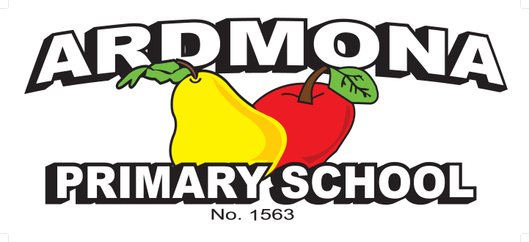

Statement of Values & School Philosophy

Purpose
The purpose of this policy is to outline the values of our school community and explain the vision, mission and objectives of our school.

Policy
Ardmona Primary School is committed to providing a safe, supportive and inclusive environment for all students, staff and members of our community. Our school recognises the importance of the partnership between our school and parents and carers to support student learning, engagement and wellbeing. We share a commitment to, and a responsibility for, creating an inclusive and safe school environment for our students.
The programs and teaching at Ardmona Primary School support and promote the principles and practice of Australian democracy, including a commitment to:
- elected government
- the rule of law
- equal rights for all before the law
- freedom of religion
- freedom of speech and association
- the values of openness and tolerance.

This policy outlines our school’s vision, mission, objective, values and expectations of our school community. This policy is available on our school website, our staff induction handbook, student diary and enrolment/transition packs.
To celebrate and embed our Statement of Values and Philosophy in our school community, we
- display posters and banners that promote your values in our school
- celebrate our values in our school newsletter
- provide awards and recognition for students who actively demonstrate the values
- discuss our values with students in the classroom, meetings and assemblies.

Vision
Ardmona Primary School’s vision is to be safe, be responsible learners so to empower students to reach personal best.

Mission




Ardmona Primary School’s mission is to lifelong learners.

580
Turnbull Road

Ardmona Vic 3629

To keep up to date follow us on:

Phone: 03 5829 0273

Fax: 03 5829 0421

Email: ardmona.ps@edumail.vic.gov.au

www.ardmonaps.vic.gov.au

580
Turnbull Road

Ardmona Vic 3629

Keep up to date by following us on:

Phone: 03 5829 0273

Fax: 03 5829 0421

Email: ardmona.ps@education.vic.gov.au

www.ardmonaps.vic.gov.au

OBJECTIVE
Ardmona Primary School’s objective is to ensure all students leave our school with a practical understanding of the curriculum and life skills.

Values
Ardmona Primary School’s values are Be Safe, Be Respectful and Be a Learners.
- We respect ourselves, our school and each other, and understand that our attitudes and safe behaviours have an impact on the people around us.
- We model and demonstrate kindness and take every opportunity to help others that may be in need.
- As learners we strive for excellence, which means trying our hardest and doing our best.

Behavioural expectations
Ardmona Primary School acknowledges that the behaviour of staff, parents, carers and students has an impact on our school community and culture.
We acknowledge a shared responsibility to create a positive learning environment for the children and young people at our school.
Shared expectations of staff, parents, carers and students to support positive student behaviour are set out in the Respectful, safe, engaged: shared expectations to support student behaviour statement.
Students are also supported by school staff to meet expected standards of behaviour as outlined in our Student Wellbeing and Engagement Policy, Inclusion and Diversity Policy, Bullying Prevention Policy.
Staff must follow our school and department policies and the Victorian Public Service Code of Conduct and Values. Teaching staff also adhere to the Victorian Teaching Profession's Code of Conduct.
Parents and carers play a vital role in helping their child understand and meet shared behaviour expectations. Additionally, information about the expectations of parents and carers to ensure schools remain respectful and inclusive places is outlined in the department’s Respectful Behaviours within the School Community Policy, and our Respect for School Staff Policy. Schools can share these expectations through use of posters available in over 30 translated languages.

Unreasonable behaviours
Schools are not public places, and the Principal has the right to permit or deny entry to school grounds (for more information, see our Visitors Policy).
Unreasonable behaviour that is demonstrated by school staff, parents, carers, students or members of our school community will not be tolerated at school, or during school activities.
Unreasonable behaviour includes:
- being violent or threatening violence of any kind, including physically intimidating behaviour such as aggressive hand gestures or invading another person’s personal space

580
Turnbull Road

Ardmona Vic 3629

To keep up to date follow us on:

Phone: 03 5829 0273

Fax: 03 5829 0421

Email: ardmona.ps@edumail.vic.gov.au

www.ardmonaps.vic.gov.au

580
Turnbull Road

Ardmona Vic 3629

Keep up to date by following us on:

Phone: 03 5829 0273

Fax: 03 5829 0421

Email: ardmona.ps@education.vic.gov.au

www.ardmonaps.vic.gov.au

- speaking or behaving in a rude, aggressive or threatening way, either in person, via email, social media, or over the telephone
- sending demanding, rude, confronting or threatening letters, emails or text messages
- discriminatory or derogatory comments
- the use of social media or public forums to make inappropriate or threatening remarks about the school, staff or students.
Harassment, bullying, violence, aggression, threatening behaviour and unlawful discrimination are unacceptable and will not be tolerated at our school.
Unreasonable behaviour and/or failure to uphold the principles of this Statement of Values and School Philosophy may lead to further investigation and the implementation of appropriate consequences by the school Principal.
At the Principal’s discretion, unreasonable behaviour may be managed by:
- requesting that the parties attend a mediation or counselling sessions
- implementing specific communication protocols
- written warnings
- conditions of entry to school grounds or school activities
- exclusion from school grounds or attendance at school activities
- reports to Victoria Police
- legal action
Inappropriate student behaviour will be managed in according with our school’s Student Wellbeing and Engagement Policy and Bullying Prevention Policy.
Our Statement of Values and School Philosophy ensures that everyone in our school community will be treated with fairness and respect. In turn, we will strive to create a school that is inclusive and safe, where everyone is empowered to participate and learn.

COMMUNICATION
This policy will be communicated to our school community in the following ways:
- Available publicly on our school’s website
- Included in staff induction processes
- Included in staff handbook/manual
- Included in transition and enrolment packs
- Included as annual reference in school newsletter
- Made available in hard copy from school administration upon request

RELATED POLICIES and resources
Department of Education policies and resources:
- Work-Related Violence in Schools Policy
- Respectful Behaviours within the School Community Policy
- Respectful, safe, engaged: shared expectations to support student behaviour

580
Turnbull Road

Ardmona Vic 3629

To keep up to date follow us on:

Phone: 03 5829 0273

Fax: 03 5829 0421

Email: ardmona.ps@edumail.vic.gov.au

www.ardmonaps.vic.gov.au

580
Turnbull Road

Ardmona Vic 3629

Keep up to date by following us on:

Phone: 03 5829 0273

Fax: 03 5829 0421

Email: ardmona.ps@education.vic.gov.au

www.ardmonaps.vic.gov.au

Policy REVIEW and Approval
Policy last reviewed | March 2026
Approved by | School Council – March 27th 2026
Next scheduled review date | March 2029

